| **Test Name** | | | Register account | | | |
| --- | --- | --- | --- | --- | --- | --- |
| **Use Case Tested:** | | | Register-Check Editable Fields | | | |
| **Test Description:** | | | Verify that registration form has input fields Username, email password and confirm password and that these are editable | | | |
| **Pre-conditions** | | | Register screen must be open | | | |
| **Post-conditions** | | | That all input fields are filled | | | |
| **Notes:** | |  | | | | |
| **Result (Pass/Fail/Warning/Incomplete)** | | **Pass** | | | | |
|  | **TEST STEP** | | | **EXPECTED TEST RESULTS** | P | F |
|  | Does Registration form have username input field | | | That input field exists | P |  |
|  | Does Registration form have email input field | | | That input field exists | P |  |
|  | Does Registration form have password input field | | | That input field exists | P |  |
|  | Does Registration form have confirm password input field | | | That input field exists | P |  |
|  | Type information into editable fields | | | That the user can type required details into input fields | p |  |
|  | Are passwords viewable | | | Passwords should show as asterisk’s | p |  |

|  |  |  |  |  |  |
| --- | --- | --- | --- | --- | --- |
| **Test Data Table** | | | | | |
|  | **1** | **2** | **3** | **4** | **5** |
| Username | tester2 |  |  |  |  |
| Email | tester2@gmail.com |  |  |  |  |
| Password 1 | tester2 |  |  |  |  |
| Password 2 | tester2 |  |  |  |  |

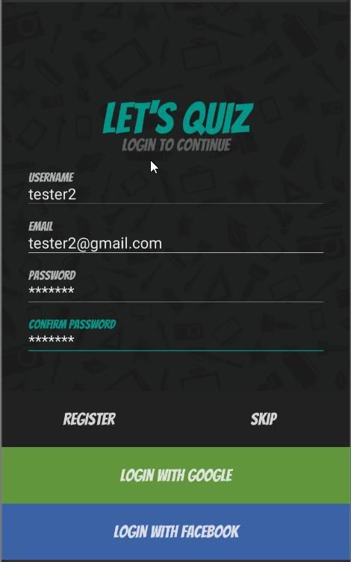

All fields editable and passwords show as asterisk

| **Test Name** | | | Register account | | | |
| --- | --- | --- | --- | --- | --- | --- |
| **Use Case Tested:** | | | Register-Blank Username | | | |
| **Test Description:** | | | Verify that entering blank spaces on username field produces error message | | | |
| **Pre-conditions** | | | Register screen must be open | | | |
| **Post-conditions** | | | Error message should be displayed | | | |
| **Notes:** | |  | | | | |
| **Result (Pass/Fail/Warning/Incomplete)** | | **Pass** | | | | |
|  | **TEST STEP** | | | **EXPECTED TEST RESULTS** | **P** | **F** |
| 1 | Leave username blank and hit register | | | Error message confirm username cannot be empty is displayed | **p** |  |

|  |  |  |  |  |  |
| --- | --- | --- | --- | --- | --- |
| **Test Data Table** | | | | | |
|  | **1** | **2** | **3** | **4** | **5** |
| Username blank | empty |  |  |  |  |
| Email | tester2@gmail.com |  |  |  |  |
| Password | tester2 |  |  |  |  |
| Confirm passwords | tester2 |  |  |  |  |

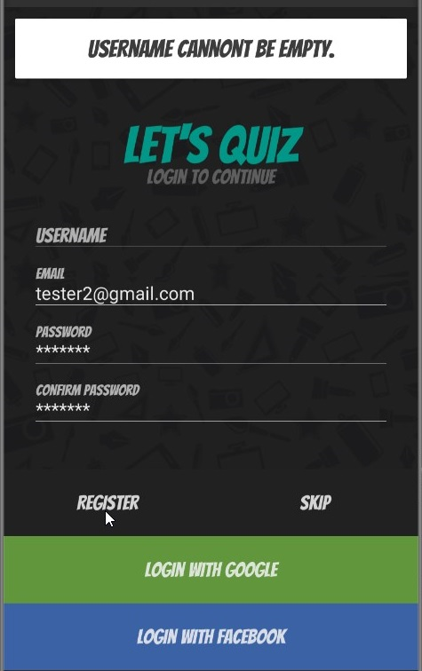

User name space empty error message displayed

| **Test Name** | | | Register account | | | |
| --- | --- | --- | --- | --- | --- | --- |
| **Use Case Tested:** | | | Register-Blank Email | | | |
| **Test Description:** | | | Verify that entering blank spaces on email field produces error message | | | |
| **Pre-conditions** | | | Register screen must be open | | | |
| **Post-conditions** | | | Error message should be displayed | | | |
| **Notes:** | |  | | | | |
| **Result (Pass/Fail/Warning/Incomplete)** | | **Pass** | | | | |
|  | **TEST STEP** | | | **EXPECTED TEST RESULTS** | P | F |
| 1 | Leave email blank and hit register | | | Error message confirm email cannot be empty is displayed | P |  |

|  |  |  |  |  |  |
| --- | --- | --- | --- | --- | --- |
| **Test Data Table** | | | | | |
|  | **1** | **2** | **3** | **4** | **5** |
| Username | tester2 |  |  |  |  |
| Email | empty |  |  |  |  |
| Password | tester2 |  |  |  |  |
| Confirm passwords | tester2 |  |  |  |  |

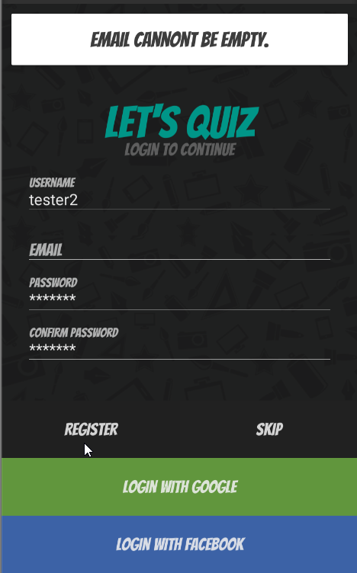

Email empty error message displayed

| **Test Name** | | | Register account | | | |
| --- | --- | --- | --- | --- | --- | --- |
| **Use Case Tested:** | | | Register-Blank password | | | |
| **Test Description:** | | | Verify that entering blank spaces on password field produces error message | | | |
| **Pre-conditions** | | | Register screen must be open | | | |
| **Post-conditions** | | | Error message should be displayed | | | |
| **Notes:** | |  | | | | |
| **Result (Pass/Fail/Warning/Incomplete)** | | **Pass** | | | | |
|  | **TEST STEP** | | | **EXPECTED TEST RESULTS** | **P** | **F** |
| 1 | Leave password blank and hit register | | | Error message confirm password cannot be empty is displayed | **P** |  |

|  |  |  |  |  |  |
| --- | --- | --- | --- | --- | --- |
| **Test Data Table** | | | | | |
|  | **1** | **2** | **3** | **4** | **5** |
| Username | Test123 |  |  |  |  |
| Email | test@test.com |  |  |  |  |
| Password 1 | Empty |  |  |  |  |
| Password 2 | Empty |  |  |  |  |

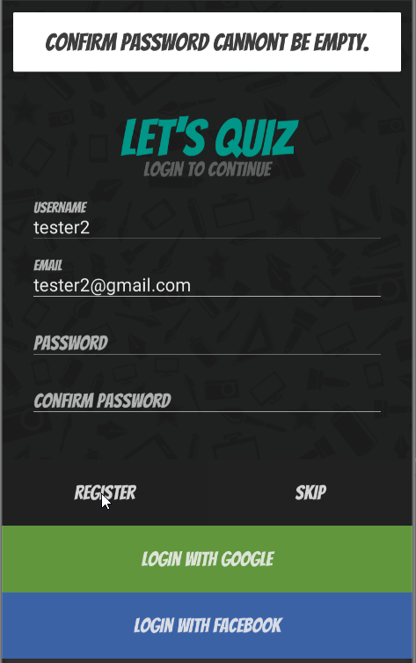

Password empty error message displayed

| **Test Name** | | | Register account | | | |
| --- | --- | --- | --- | --- | --- | --- |
| **Use Case Tested:** | | | Register-Blank confirm password | | | |
| **Test Description:** | | | Verify that entering blank spaces on password field produces error message | | | |
| **Pre-conditions** | | | Register screen must be open | | | |
| **Post-conditions** | | | Error message should be displayed | | | |
| **Notes:** | |  | | | | |
| **Result (Pass/Fail/Warning/Incomplete)** | | **Pass** | | | | |
|  | **TEST STEP** | | | **EXPECTED TEST RESULTS** | **P** | **F** |
| 1 | Leave confirm password blank and hit register | | | Error message passwords don’t match, try again should display | **P** |  |

|  |  |  |  |  |  |
| --- | --- | --- | --- | --- | --- |
| **Test Data Table** | | | | | |
|  | **1** | **2** | **3** | **4** | **5** |
| Username | tester2 |  |  |  |  |
| Email | tester2@gmail.com |  |  |  |  |
| Password 1 | tester2 |  |  |  |  |
| Password 2 | Empty |  |  |  |  |

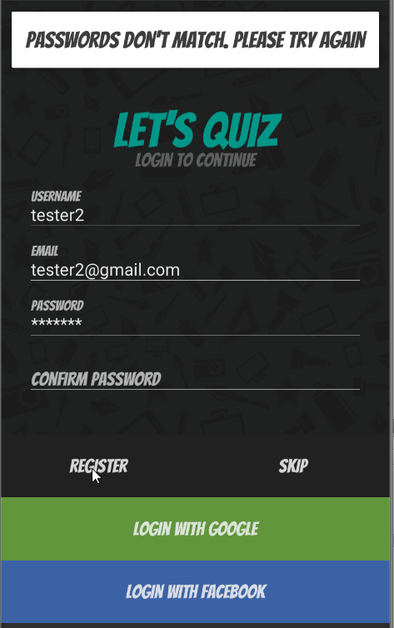

Second password empty error message displayed

| **Test Name** | | | Register account | | | |
| --- | --- | --- | --- | --- | --- | --- |
| **Use Case Tested:** | | | Register-Passwords Match | | | |
| **Test Description:** | | | Verify whether the password and confirm password send error message when they don’t match each other | | | |
| **Pre-conditions** | | | Register screen must be open | | | |
| **Post-conditions** | | | Error message should be displayed | | | |
| **Notes:** | | **Round 1 Test failed it logged tester2 in** | | | | |
| **Result (Pass/Fail/Warning/Incomplete)** | | **Failed first run**  **Passed second run** | | | | |
|  | **TEST STEP** | | | **EXPECTED TEST RESULTS** | **P** | **F** |
| Run 1 | Enter to different passwords | | | Error message passwords don’t match, try again should display |  | **F** |
| Run 2 | Enter to different passwords | | | Error message passwords don’t match, try again should display | **P** |  |

|  |  |  |  |  |  |
| --- | --- | --- | --- | --- | --- |
| **Test Data Table** | | | | | |
|  | **1** | **2** | **3** | **4** | **5** |
| Username | tester2 | Tester3 |  |  |  |
| Email | tester2@gmail.com | tester3@gmail.com |  |  |  |
| Password 1 | tester2 | tester3 |  |  |  |
| Password 2 | tes124 | tes124 |  |  |  |

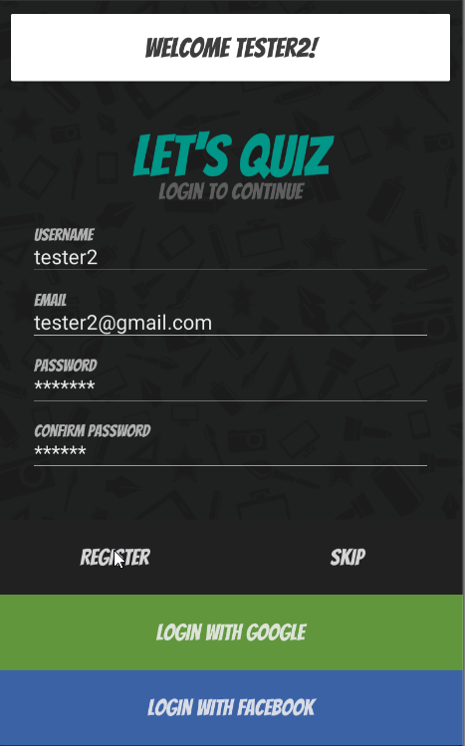

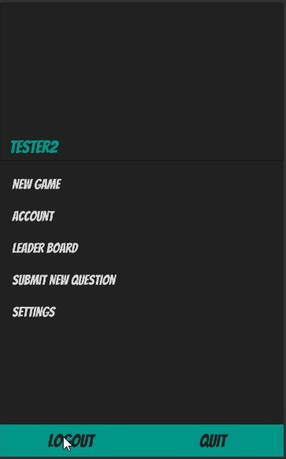

Signed tester 2 in welcome tester2 displayed when no sign in should have occurred error message should say

passwords don’t match, try again.

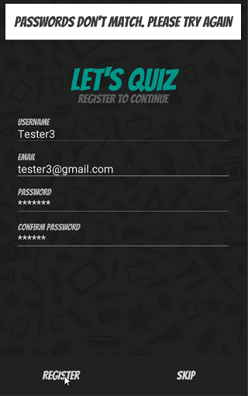

Displayed passwords don’t match

| **Test Name** | | | Register account | | | |
| --- | --- | --- | --- | --- | --- | --- |
| **Use Case Tested:** | | | Register- Submittal | | | |
| **Test Description:** | | | Verify that clicking on register button after entering all the mandatory fields, submits the data to the server | | | |
| **Pre-conditions** | | | Register screen must be open  Internet connection must exist | | | |
| **Post-conditions** | | | User must successfully register | | | |
| **Notes:** | |  | | | | |
| **Result (Pass/Fail/Warning/Incomplete)** | | **Pass** | | | | |
|  | **TEST STEP** | | | **EXPECTED TEST RESULTS** | **P** | **F** |
| 1 | Enter username | | | Username will be filled in | **P** |  |
| 2 | Enter email | | | Email will be filled in | **P** |  |
| 3 | Enter password | | | Password will be filled in | **P** |  |
| 4 | Enter password a second time to confirm | | | Password will be filled in | **P** |  |
| 5 | Hit register button | | | Details should be sent to server and account created and user account page should open | **P** |  |

|  |  |  |  |  |  |
| --- | --- | --- | --- | --- | --- |
| **Test Data Table** | | | | | |
|  | **1** | **2** | **3** | **4** | **5** |
| Username | tester2 |  |  |  |  |
| Email | tester2@gmail.com |  |  |  |  |
| Password 1 | tester2 |  |  |  |  |
| Password 2 | tester2 |  |  |  |  |

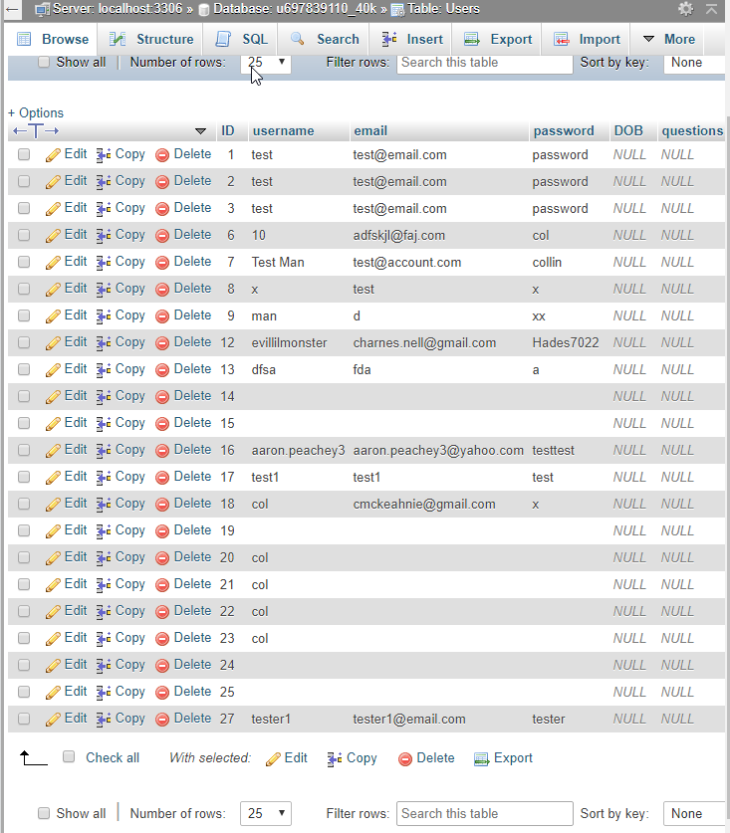

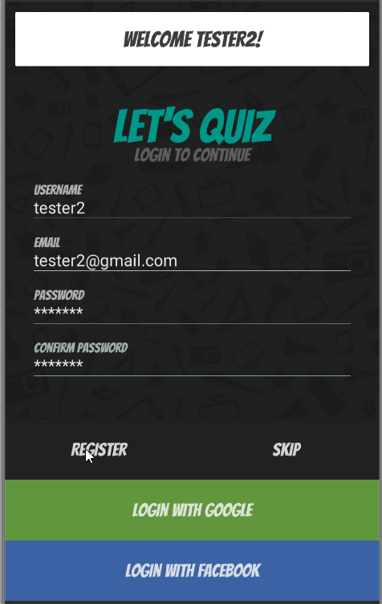

Database without tester2 account Details entered register pressed and welcome message displayed

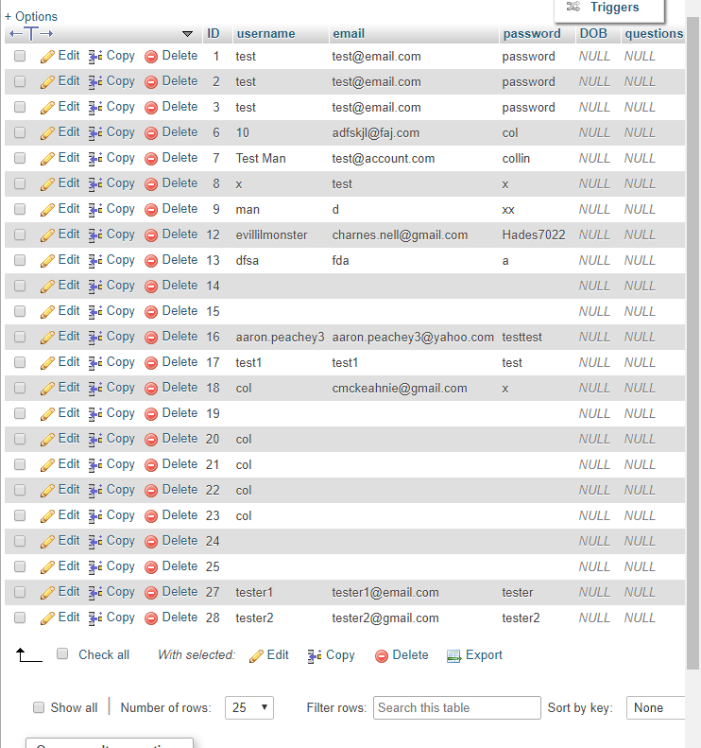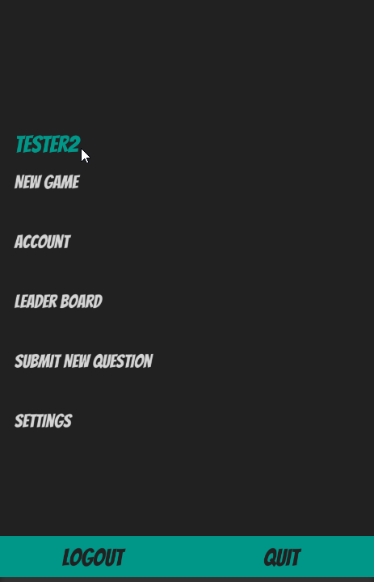

Scene changes to new game screen shows tester2 is logged in Database showing tester2 account details

| **Test Name** | | | Register account | | | |
| --- | --- | --- | --- | --- | --- | --- |
| **Use Case Tested:** | | | Register-Skip Registration | | | |
| **Test Description:** | | | Verify that pressing skip button works to advance forward or go back to register | | | |
| **Pre-conditions** | | | Register screen must be open | | | |
| **Post-conditions** | | | Warning should be displayed allowing user to either continue as guest or exit back to register page | | | |
| **Notes:** | | **Name should have changed to guest not part of this test**  **Second run passed** | | | | |
| **Result (Pass/Fail/Warning/Incomplete)** | | **Failed first run**  **Passed second run** | | | | |
|  | **TEST STEP** | | | **EXPECTED TEST RESULTS** | **P** | **F** |
| 1 | Press skip button | | | Should display warning that informs user registering as a guest limits what you can do with a confirmation button or cancel button | **P** |  |
| 2 | Press confirmation button(register) on warning panel | | | Should advance to game choose panel | **P** |  |
| 3 | User name should change when on new game screen | | | Should say Guest and limit options |  | **F** |
| 4 | Press return button(cancel) on warning panel | | | Should return to register panel | **P** |  |
|  |  | | |  |  |  |
| 1 | Press skip button | | | Should display warning that informs user registering as a guest limits what you can do with a confirmation button or cancel button | **P** |  |
| 2 | Press confirmation button(register) on warning panel | | | Should advance to game choose panel | **P** |  |
| 3 | User name should change when on new game screen | | | Should say Guest and limit options | **P** |  |
| 4 | Press return button(cancel) on warning panel | | | Should return to register panel | **P** |  |

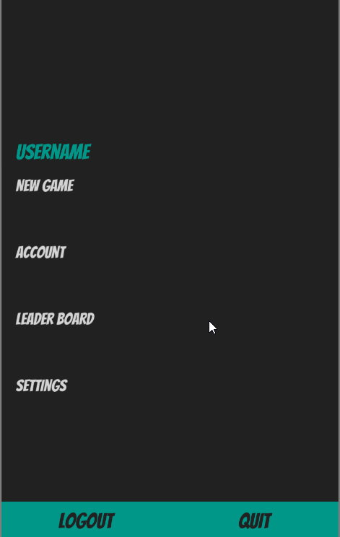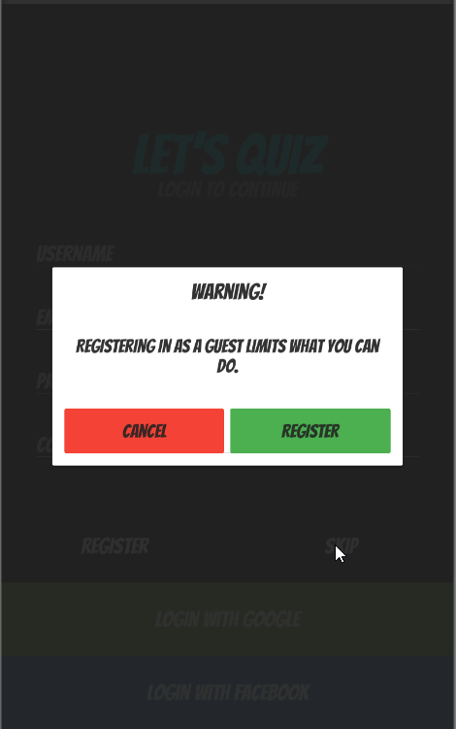

Hit skip warning displayed Hit register logged in as guest but no name change and options not limited

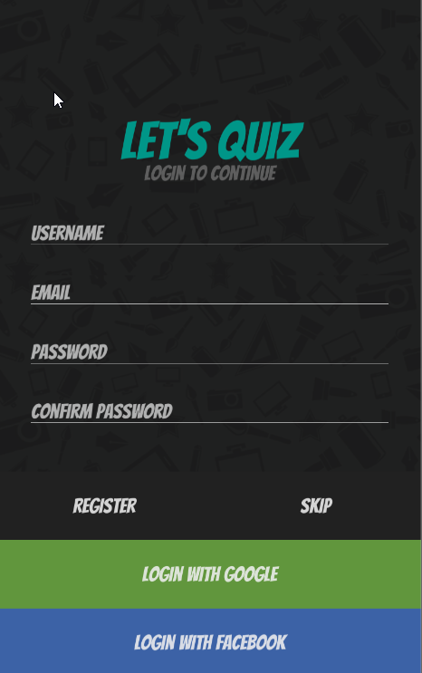

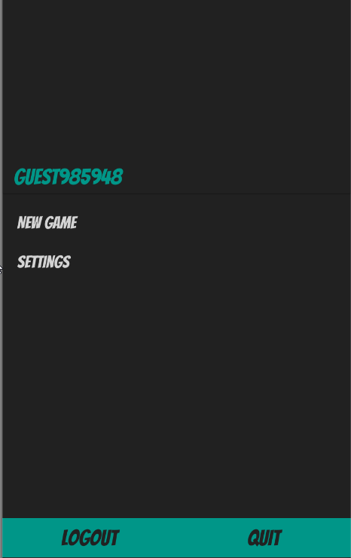

Hit cancel returned to register screen Second run changed to guest and limited options